SPRINT-3

|  |  |
| --- | --- |
| TEAM ID | PNT2022TMID40035 |
| Project Name | IoT Based smart crop Protection system for agriculture |

STEP1:Simulatedprogramtogettherandomvalues. 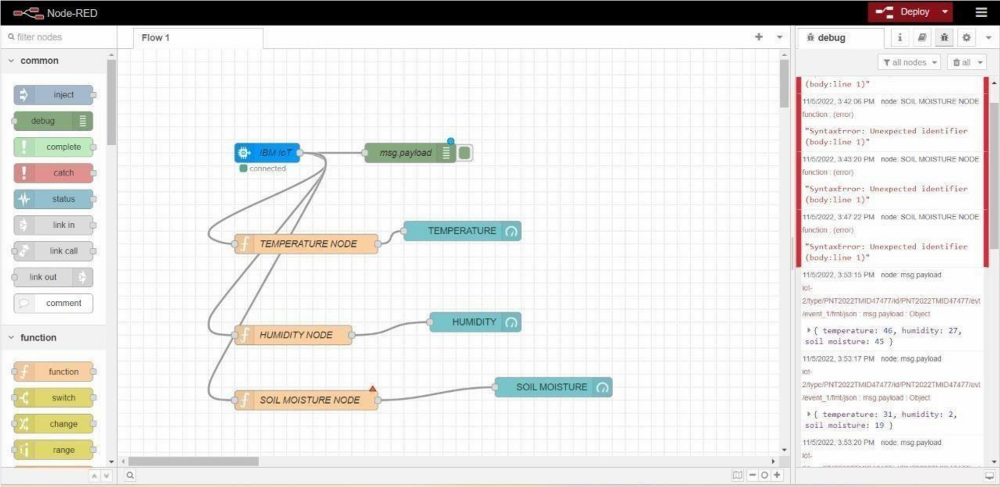

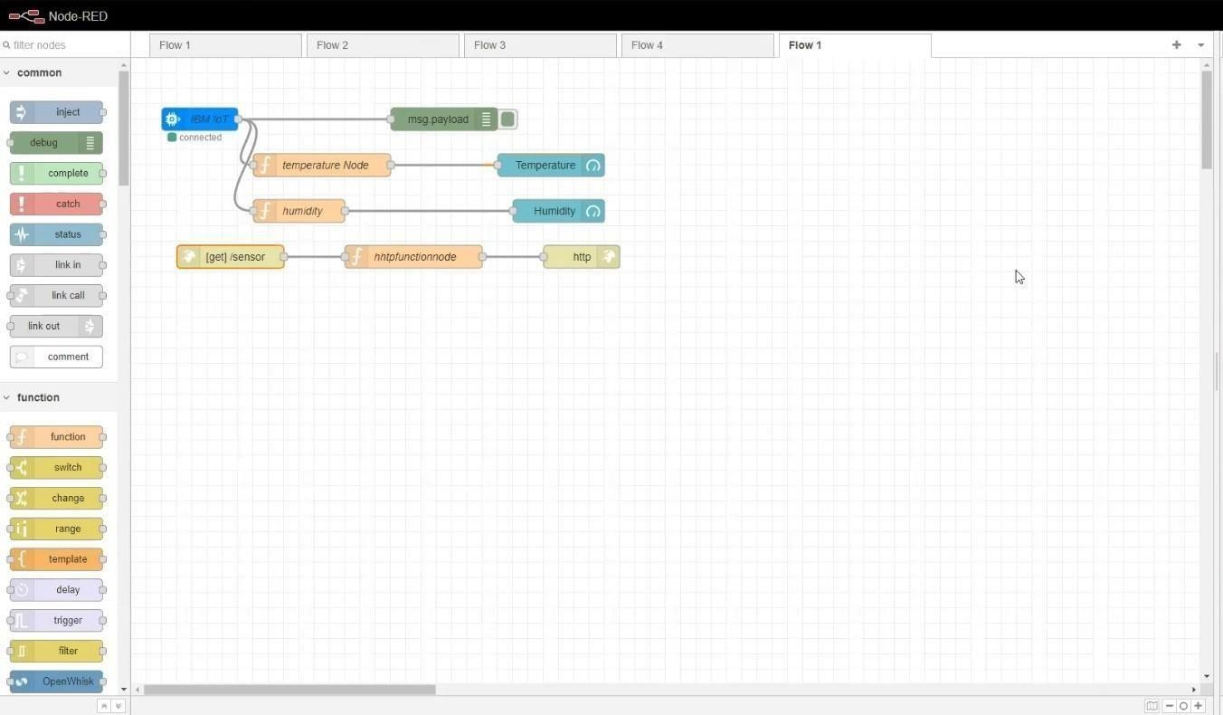

STEP2: Generate debug message from IBM Watson IoT Platform and connect the nodes.STEP3:Generatethe someoutput fromrecentevents. 